Sprint 4 Report
Last Revised:
(December 1, 2025 - December 2, 2025)

SlugConnect
Elian - product owner (e.g. product owner / developer)
Sam - Scrum Master
Tyler - Developer
Neha - Developer
Dean - Developer
Actions to Stop Doing
- The team should stop setting time for stretch goals since more testing is needed for a working prototype.
Actions to Start Doing
- The team should set some time aside to test the product, since the team is nearing the end of the sprint and will have to demo a working MVP.

Actions to Keep Doing
- The team should continue working on tasks/user stories that need to be completed in order to meet the MVP so that we can demo what we have, since this is the last sprint of the quarter (the end of the project). The team should also continue communicating on what has been done (contribution to the project and final documents) so that the team is prepared for the project review.

Work Completed / Not Completed
- Completed:
  - Ability to send connection requests to other students
  - Ability to reject connection requests from other students
  - Make edits to my profile
  - Email Confirmation
  - Data persistence across pages
- Not Completed:
  - Interest-based groups
  - Posts in interest-based groups

Work Completion Rate
- 95.8 %
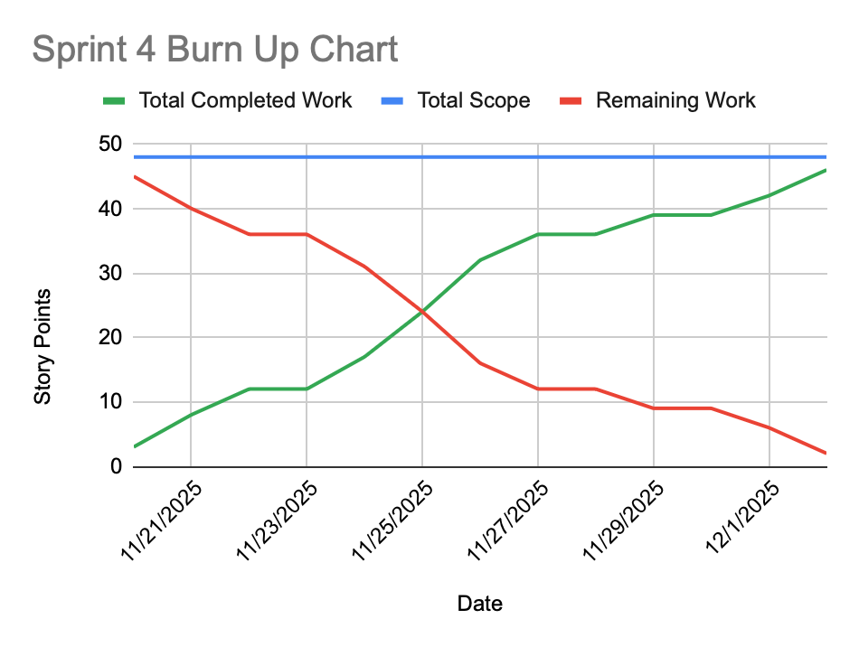
(Full Burn Up Chart spreadsheet is linked to graph)

